**INTER-VLAN ROUTING**

4.0.1

Why should I take this module?

Welcome to Inter-VLAN Routing!

Now you know how to segment and organize your network into VLANs. Hosts can communicate with other hosts in the same VLAN, and you no longer have hosts sending out broadcast messages to every other device in your network, eating up needed bandwidth.

But what if a host in one VLAN needs to communicate with a host in a different VLAN? If you are a network administrator, you know that people will want to communicate with other people outside of your network. This is where inter-VLAN routing can help you. Inter-VLAN routing uses a Layer 3 device such as a router or a Layer 3 switch. Let’s take your VLAN expertise and combine it with your network layer skills and put them to the test!

4.0.2

What will I learn to do in this module?

**Module Title: Inter-VLAN Routing**

**Module Objective**: Troubleshoot inter-VLAN routing on Layer 3 devices.

| Table caption | |
| --- | --- |
| **Topic Title** | **Topic Objective** |
| **Inter-VLAN Routing Operation** | Describe options for configuring inter-VLAN routing. |
| **Router-on-a-Stick Inter-VLAN Routing** | Configure router-on-a-stick inter-VLAN routing. |
| **Inter-VLAN Routing using Layer 3 Switches** | Configure inter-VLAN routing using Layer 3 switching. |
| **Troubleshoot Inter-VLAN Routing** | Troubleshoot common inter-VLAN configuration issues. |

**INTER-VLAN ROUTING OPERATION**

4.1.1

## What is Inter-VLAN Routing?

VLANs are used to segment switched Layer 2 networks for a variety of reasons. Regardless of the reason, hosts in one VLAN cannot communicate with hosts in another VLAN unless there is a router or a Layer 3 switch to provide routing services.

***Inter-VLAN routing*** is the process of forwarding network traffic from one VLAN to another VLAN.

There are three inter-VLAN routing options:

* **Legacy Inter-VLAN routing** - This is a legacy solution. It does not scale well.
* **Router-on-a-Stick** - This is an acceptable solution for a small to medium-sized network.
* **Layer 3 switch using switched virtual interfaces (SVIs)** - This is the most scalable solution for medium to large organizations.

4.1.2

## Legacy Inter-VLAN Routing

The first inter-VLAN routing solution relied on using a router with multiple Ethernet interfaces.

Each router interface was connected to a switch port in different VLANs. The router interfaces served as the default gateways to the local hosts on the VLAN subnet.

For example, refer to the topology where R1 has two interfaces connected to switch S1.

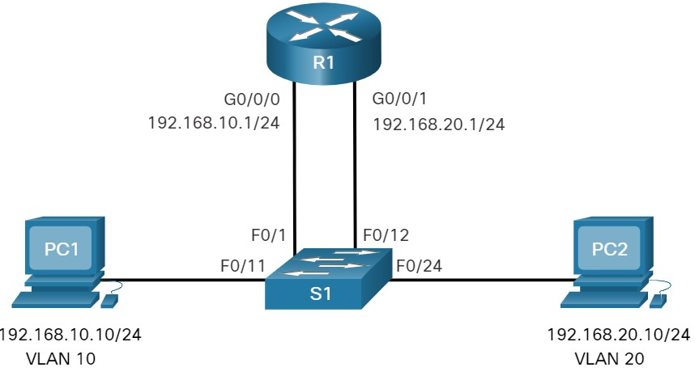

Notice in the example MAC address table of S1 is populated as follows:

* Fa0/1 port is assigned to VLAN 10 and is connected to the R1 G0/0/0 interface.
* Fa0/11 port is assigned to VLAN 10 and is connected to PC1.
* Fa0/12 port is assigned to VLAN 20 and is connected to the R1 G0/0/1 interface.
* Fa0/24 port is assigned to VLAN 20 and is connected to PC2.

### **MAC Address table for S1**

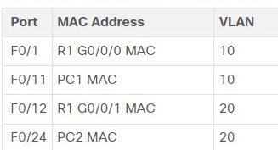

When PC1 sends a packet to PC2 on another network, it forwards it to its default gateway 192.168.10.1. R1 receives the packet on its G0/0/0 interface and examines the destination address of the packet.

R1 then routes the packet out its G0/0/1 interface to the F0/12 port in VLAN 20 on S1. Finally, S1 forwards the frame to PC2.

Legacy inter-VLAN routing using physical interfaces works, but it has a significant limitation.

It is not ***reasonably scalable*** because routers have a limited number of physical interfaces. Requiring one physical router interface per VLAN quickly exhausts the physical interface capacity of a router.

In our example, R1 required two separate Ethernet interfaces to route between VLAN 10 and VLAN 20. What if there were six (or more) VLANs to interconnect? A separate interface would be required for each VLAN. Obviously, this solution is not scalable.

**Note**: This method of inter-VLAN routing is no longer implemented in switched networks and is included for explanation purposes only.

4.1.3

## Router-on-a-Stick Inter-VLAN Routing

The ‘***router-on-a-stick’*** inter-VLAN routing method overcomes the limitation of the legacy inter-VLAN routing method. It only requires ***one physical Ethernet interface*** to route traffic between multiple VLANs on a network.

A Cisco IOS router Ethernet interface is configured as an 802.1Q trunk and connected to a trunk port on a Layer 2 switch. Specifically, the router interface is configured using subinterfaces to identify routable VLANs.

The configured subinterfaces are software-based virtual interfaces. Each is associated with a single physical Ethernet interface.

Subinterfaces are configured in software on a router. Each subinterface is independently configured with an IP address and VLAN assignment. Subinterfaces are configured for different subnets that correspond to their VLAN assignment. This facilitates logical routing.

When VLAN-tagged traffic enters the router interface, it is forwarded to the VLAN subinterface. After a routing decision is made based on the destination IP network address, the router determines the exit interface for the traffic. If the exit interface is configured as an 802.Q subinterface, the data frames are VLAN-tagged with the new VLAN and sent back out the physical interface.

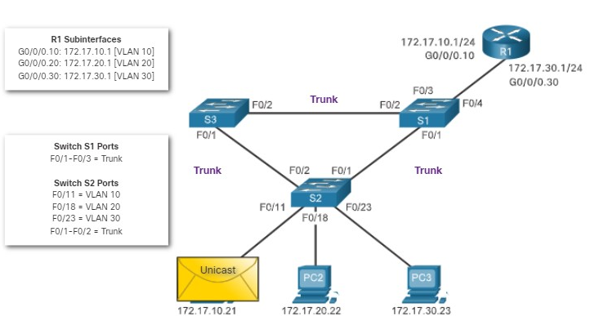

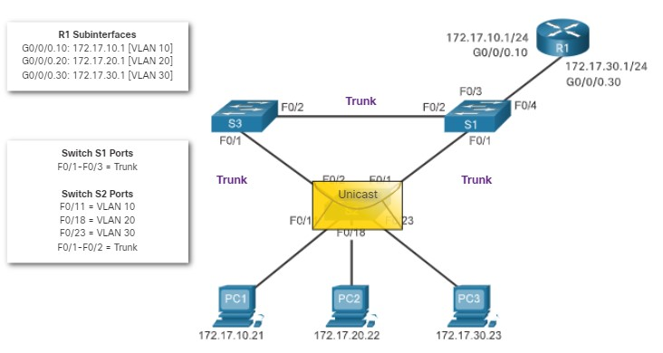

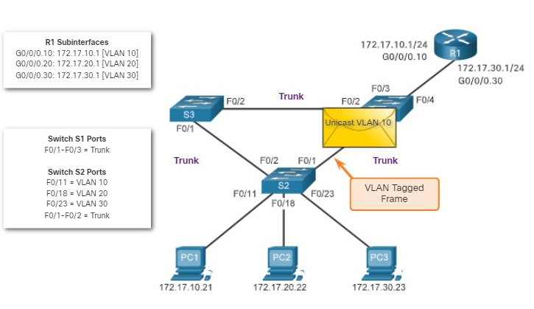

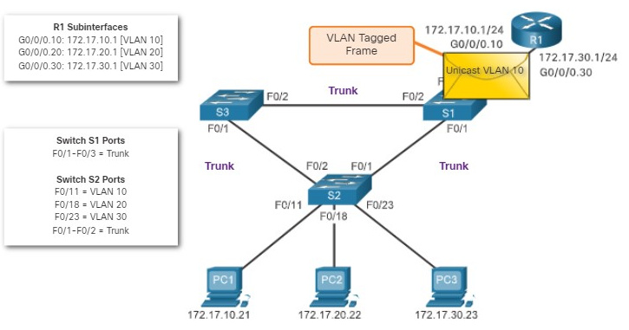

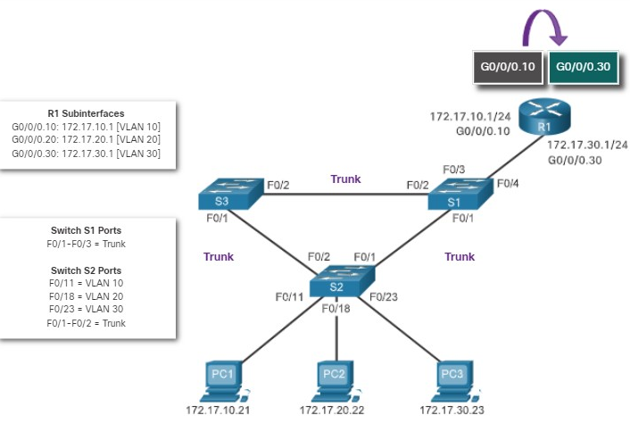

As seen in the animation, PC1 on VLAN 10 is communicating with PC3 on VLAN 30. When R1 accepts the tagged unicast traffic on VLAN 10, it routes that traffic to VLAN 30, using its configured subinterfaces. Switch S2 removes the VLAN tag of the unicast frame and forwards the frame out to PC3 on port F0/23.

**Note**: The router-on-a-stick method of inter-VLAN routing does not scale beyond 50 VLANs

4.1.4

## Inter-VLAN Routing on a Layer 3 Switch

The modern method of performing inter-VLAN routing is to use Layer 3 switches and switched virtual interfaces (SVI). An SVI is a virtual interface that is configured on a Layer 3 switch, as shown in the figure.

**Note**: A Layer 3 switch is also called a ***multilayer switch*** as it operates at Layer 2 and Layer 3. However, in this course we use the term Layer 3 switch.

The physical network topology shows two PCs, two Layer 2 switches, and a Layer 3 switch. The PC on the left is in VLAN 10 and is connected to a Layer 2 switch which in turn is connected to the Layer 3 switch. The PC on the right is in VLAN 20 and is connected to a Layer 2 switch which in turn is connected to the Layer 3 switch. The Layer 3 switch has two SVI interfaces. SVI1 is in VLAN 10 and has IP address 10.1.10.1. SVI2 is in VLAN 20 and has IP address 10.1.20.1.

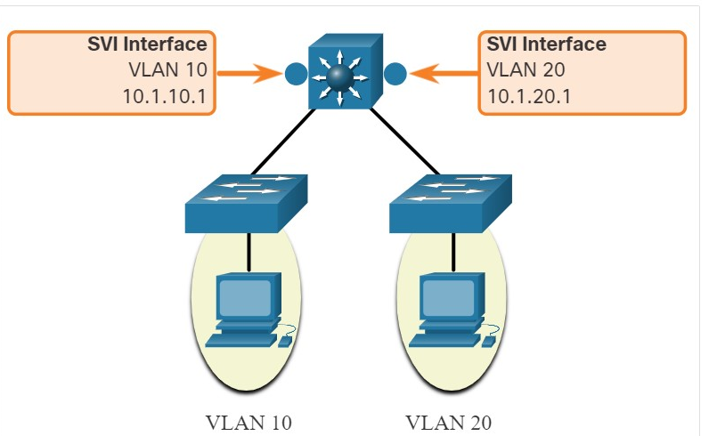

Inter-VLAN SVIs are created the same way that the management VLAN interface is configured. The SVI is created for a VLAN that exists on the switch.

Although virtual, the SVI performs the same functions for the VLAN as a router interface would. Specifically, it provides Layer 3 processing for packets that are sent to or from all switch ports associated with that VLAN.

The following are advantages of using Layer 3 switches for inter-VLAN routing:

* They are much faster than router-on-a-stick because everything is hardware switched and routed.
* There is no need for external links from the switch to the router for routing.
* They are not limited to one link because Layer 2 EtherChannels can be used as trunk links between the switches to increase bandwidth.
* Latency is much lower because data does not need to leave the switch in order to be routed to a different network.
* They more commonly deployed in a campus LAN than routers.

The only disadvantage is that Layer 3 switches are more expensive.

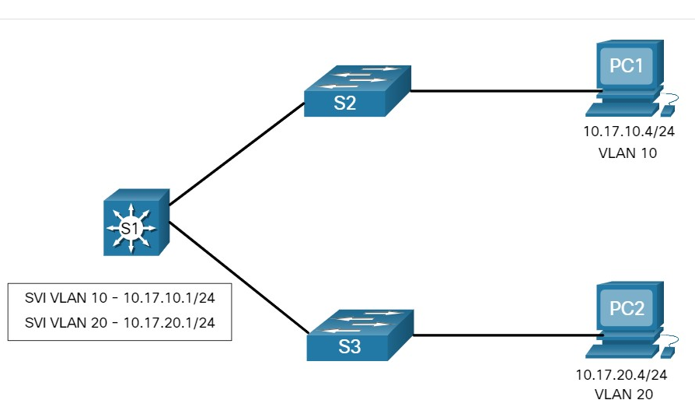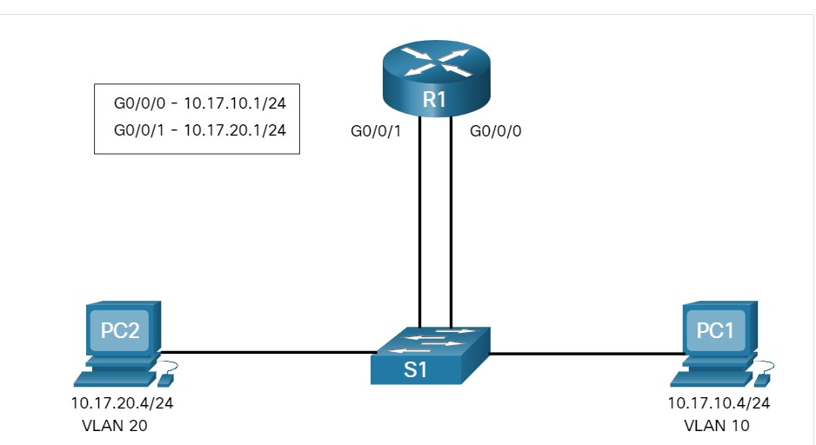

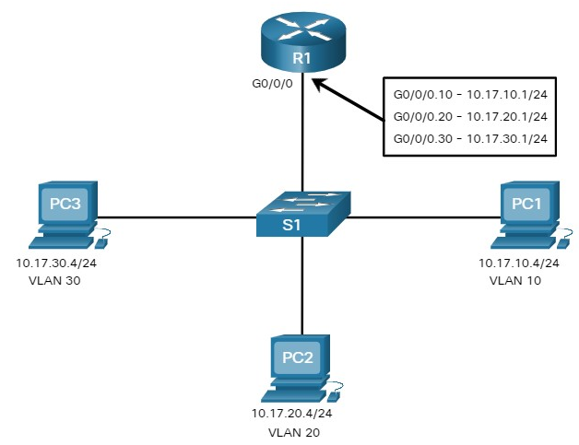

1. **Refer to each of the scenario topologies**. Which statements best describe the different types of inter-VLAN routing solutions? (Choose all that apply.)



Scenario A is a legacy inter-VLAN solution.



Scenario B is a Layer 3 inter-VLAN solution.



Scenario B and C are both Router-on-a-stick inter-VLAN solutions.



Scenario A is a Layer 3 inter-VLAN solution.



Scenario B is a legacy inter-VLAN solution.



Scenario C is a router-on-a-stick inter-VLAN solution.

* **Scenario A is a Layer 3 inter-VLAN solution.**
* **Scenario B is a legacy inter-VLAN solution.**
* **Scenario C is a router-on-a-stick inter-VLAN solution.**

4.2.1

## Router-on-a-Stick Scenario

In the previous topic, three different ways to create inter-VLAN routing were listed, and legacy inter-VLAN routing was detailed. This topic details how to configure router-on-a-stick inter-VLAN routing. You can see in the figure that the router is not in the center of the topology but instead, appears to be on a stick near the border, hence the name.

In the figure, the R1 GigabitEthernet 0/0/1 interface is connected to the S1 FastEthernet 0/5 port. The S1 FastEthernet 0/1 port is connected to the S2 FastEthernet 0/1 port. These are trunk links that are required to forward traffic within and between VLANs.

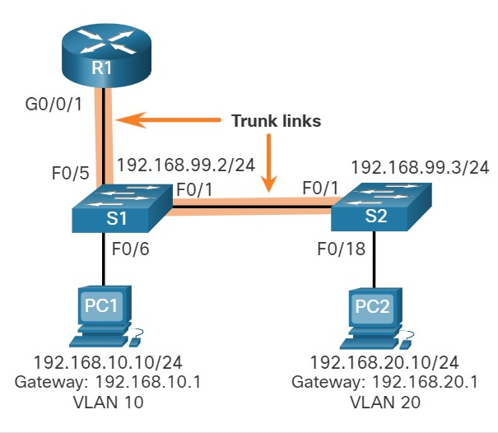

To route between VLANs, the R1 GigabitEthernet 0/0/1 interface is logically divided into three subinterfaces, as shown in the table. The table also shows the three VLANs that will be configured on the switches.

### **Router R1 Subinterfaces**

| **Subinterface** | **VLAN** | **IP Address** |
| --- | --- | --- |
| G0/0/1.10 | 10 | 192.168.10.1/24 |
| G0/0/1.20 | 20 | 192.168.20.1/24 |
| G0/0/1.99 | 99 | 192.168.99.1/24 |

Assume that R1, S1, and S2 have initial basic configurations. Currently, PC1 and PC2 cannot **ping** each other because they are on separate networks. Only S1 and S2 can **ping** each other, but they but are unreachable by PC1 or PC2 because they are also on different networks.

To enable devices to ping each other, the switches must be configured with VLANs and trunking, and the router must be configured for inter-VLAN routing.

4.2.2

## S1 VLAN and Trunking Configuration

Complete the following steps to configure S1 with VLANs and trunking:

**Step 1**. Create and name the VLANs.

**Step 2**. Create the management interface.

**Step 3**. Configure access ports.

**Step 4**. Configure trunking ports.

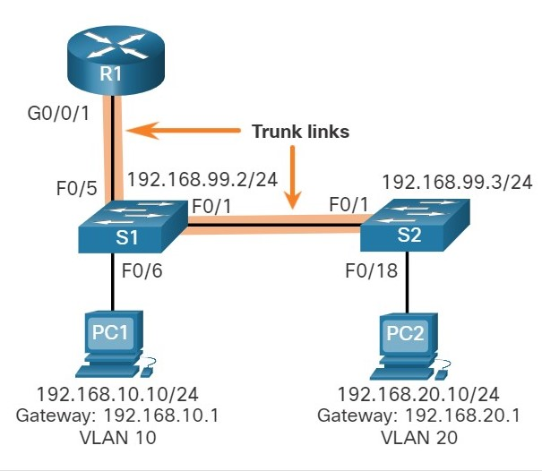

**1. Create and name the VLANs.**

First, the VLANs are created and named. VLANs are only created after you exit out of VLAN subconfiguration mode.

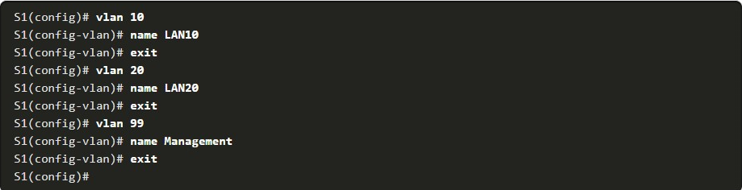

**2. Create the management interface.**

Next, the management interface is created on VLAN 99 along with the default gateway of R1.

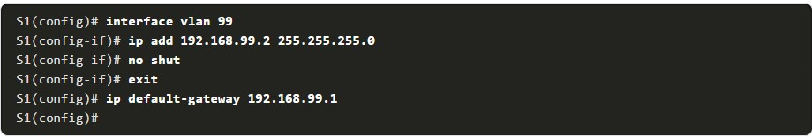

**3. Configure access ports.**

Next, port Fa0/6 connecting to PC1 is configured as an access port in VLAN 10. Assume PC1 has been configured with the correct IP address and default gateway.

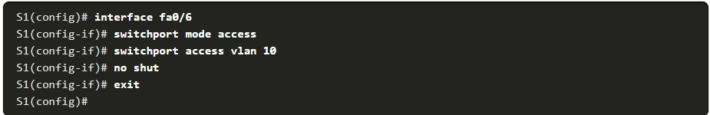

**4. Configure trunking ports.**

Finally, ports Fa0/1 connecting to S2 and Fa05 connecting to R1 are configured as trunk ports

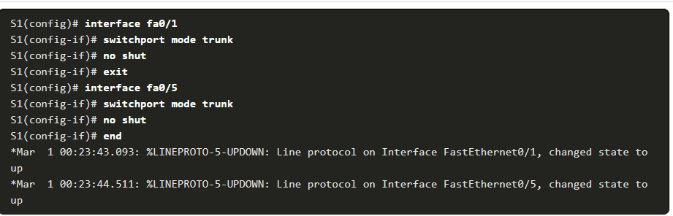

4.2.3

## S2 VLAN and Trunking Configuration

The configuration for S2 is similar to S1.

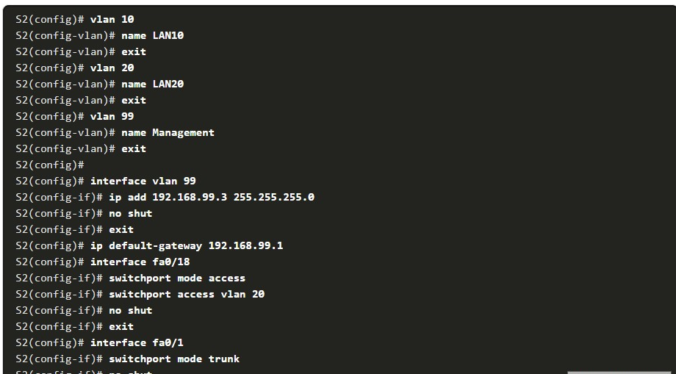

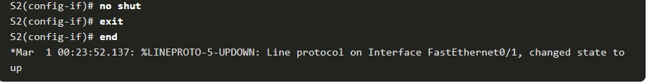

4.2.4

R1 Subinterface Configuration

The router-on-a-stick method requires you to create a subinterface for each VLAN to be routed.

A subinterface is created using the **interface** *interface_id.subinterface_id* global configuration mode command.

The subinterface syntax is the physical interface followed by a period and a subinterface number. Although not required, it is customary to match the subinterface number with the VLAN number.

Each subinterface is then configured with the following two commands:

* **Encapsulation dot1q** *vlan_id* **[native]** - This command configures the subinterface to respond to 802.1Q encapsulated traffic from the specified *vlan-id*. The **native** keyword option is only appended to set the native VLAN to something other than VLAN 1.
* **ip address** *ip-address subnet-mask* - This command configures the IPv4 address of the subinterface. This address typically serves as the default gateway for the identified VLAN.

Repeat the process for each VLAN to be routed. Each router subinterface must be assigned an IP address on a unique subnet for routing to occur.

When all subinterfaces have been created, enable the physical interface using the **no shutdown** interface configuration command. If the physical interface is disabled, all subinterfaces are disabled.

In the following configuration, the R1 G0/0/1 subinterfaces are configured for VLANs 10, 20, and 99.

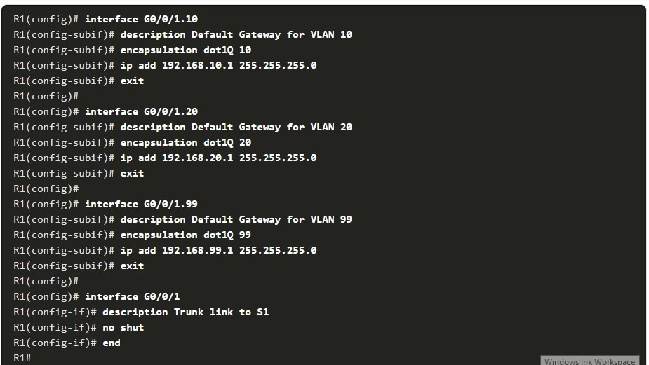



4.2.5

## Verify Connectivity Between PC1 and PC2

The router-on-a-stick configuration is complete after the switch trunk and the router subinterfaces have been configured. The configuration can be verified from the hosts, router, and switch.

From a host, verify connectivity to a host in another VLAN using the **ping** command. It is a good idea to first verify the current host IP configuration using the **ipconfig** Windows host command.

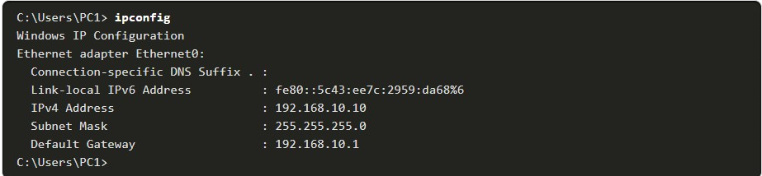

The output confirms the IPv4 address and default gateway of PC1. Next, use **ping** to verify connectivity with PC2 and S1, as shown in the figure. The **ping** output successfully confirms inter-VLAN routing is operating.

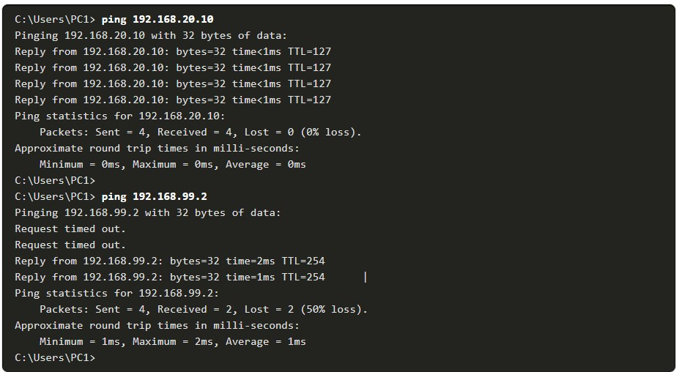

4.2.6

Router-on-a-Stick Inter-VLAN Routing Verification

In addition to using **ping** between devices, the following **show** commands can be used to verify and troubleshoot the router-on-a-stick configuration.

* **show ip route**
* **show ip interface brief**
* **show interfaces**
* **show interfaces trunk**

**show ip route**

Verify that the subinterfaces are appearing in the routing table of R1 by using the **show ip route** command. Notice that there are three connected routes (C) and their respective exit interfaces for each routable VLAN. The output confirms that the correct subnets, VLANs, and subinterfaces are active.

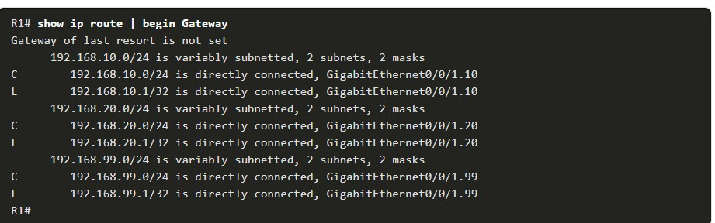

**Show ip interface brief**

Another useful router command is **show ip interface brief,** as shown in the output. The output confirms that the subinterfaces have the correct IPv4 address configured, and that they are operational.

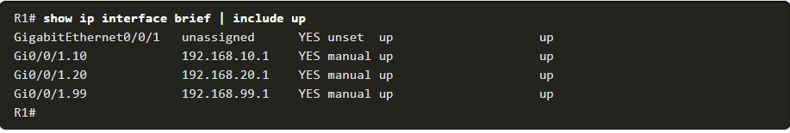

**Show interfaces**

Subinterfaces can be verified using the **show interfaces** subinterface-id command, as shown. 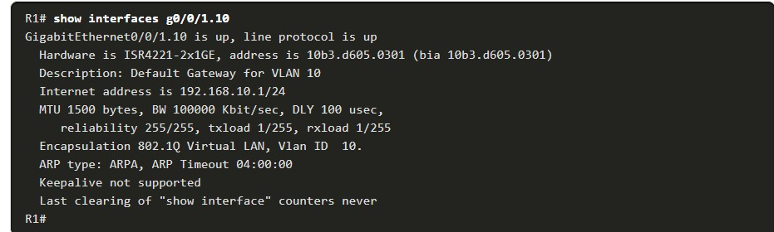

**show interfaces trunk**

The misconfiguration could also be on the trunking port of the switch. Therefore, it is also useful to verify the active trunk links on a Layer 2 switch by using the **show interfaces trunk** command, as shown in the output. The output confirms that the link to R1 is trunking for the required VLANs.

**Note:** Although VLAN 1 was not explicitly configured, it was automatically included because control traffic on trunk links will always be forwarded on VLAN 1.

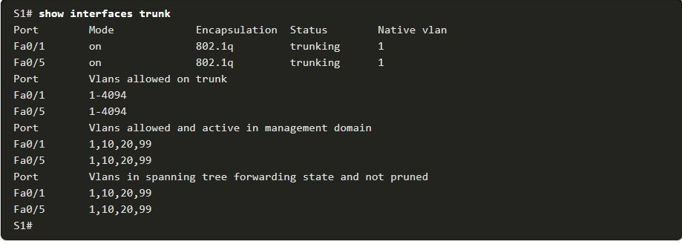

4.2.7

## Packet Tracer - Configure Router-on-a-Stick Inter-VLAN Routing (pending)

In this activity, you will check for connectivity prior to implementing inter-VLAN routing. Then you will configure VLANs and inter-VLAN routing. Finally, you will enable trunking and verify connectivity between VLANs.

4.2.8

Lab - Configure Router-on-a-Stick Inter-VLAN Routing

In this lab, you will complete the following objectives:

* Part 1: Build the Network and Configure Basic Device Settings
* Part 2: Configure Switches with VLANs and Trunking
* Part 3: Configure Trunk-Based Inter-VLAN Routing

**INTERVLAN-ROUTING USING LAYER 3 SWITCH**

4.3.1

Layer 3 Switch Inter-VLAN Routing

Modern, enterprise networks rarely use router-on-a-stick because it does not scale easily to meet requirements. In these very large networks, network administrators use Layer 3 switches to configure inter-VLAN routing.

Inter-VLAN routing using the router-on-a-stick method is simple to implement for a ***small to medium-sized organization.*** However, a large enterprise requires a faster, much more scalable method to provide inter-VLAN routing.

Enterprise campus LANs use Layer 3 switches to provide inter-VLAN routing. Layer 3 switches use hardware-based switching to achieve higher-packet processing rates than routers. Layer 3 switches are also commonly implemented in enterprise distribution layer wiring closets.

Capabilities of a Layer 3 switch include the ability to do the following:

* Route from one VLAN to another using multiple switched virtual interfaces (SVIs).
* Convert a Layer 2 switchport to a Layer 3 interface (i.e., a routed port). A routed port is similar to a physical interface on a Cisco IOS router.

To provide inter-VLAN routing, Layer 3 switches use SVIs. SVIs are configured using the same **interface vlan** *vlan-id* command used to create the management SVI on a Layer 2 switch. A Layer 3 SVI must be created for each of the routable VLANs.

4.3.2

## Layer 3 Switch Scenario

In the figure, the Layer 3 switch, D1, is connected to two hosts on different VLANs. PC1 is in VLAN 10 and PC2 is in VLAN 20, as shown. The Layer 3 switch will provide inter-VLAN routing services to the two hosts.

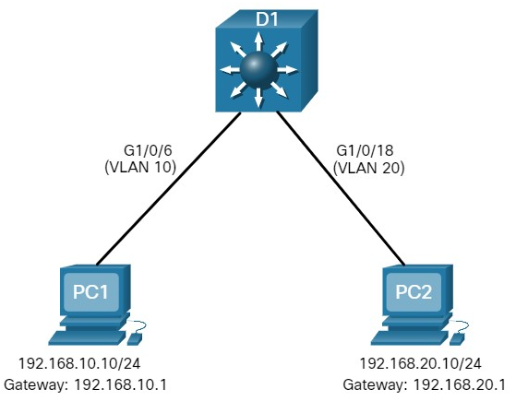

The table shows the IP addresses for each VLAN.

### **D1 VLAN IP Addresses**

| **VLAN Interface** | **IP Address** |
| --- | --- |
| 10 | 192.168.10.1/24 |
| 20 | 192.168.20.1/24 |

4.3.3

Layer 3 Switch Configuration

Complete the following steps to configure S1 with VLANs and trunking:

**Step 1**. Create the VLANs.

**Step 2**. Create the SVI VLAN interfaces.

**Step 3**. Configure access ports.

**Step 4**. Enable IP routing.

**1. Create the VLANs.**

First, create the two VLANs as shown in the output.

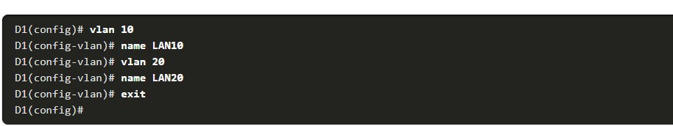

**2. Create the SVI VLAN interfaces.**

Configure the SVI for VLANs 10 and 20. The IP addresses that are configured will serve as the default gateways to the hosts in the respective VLANs. Notice the informational messages showing the line protocol on both SVIs changed to up.

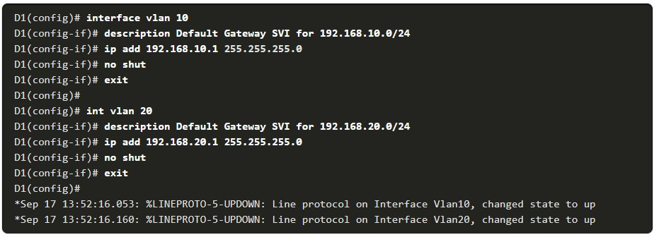

**3. Configure access ports.**

Next, configure the access ports connecting to the hosts and assign them to their respective VLANs.

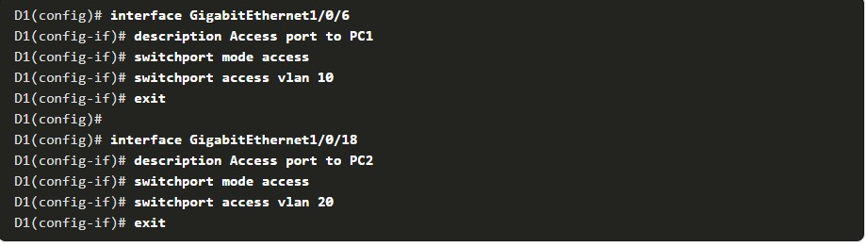

**4. Enable IP routing.**

Finally, enable IPv4 routing with the **ip routing** global configuration command to allow traffic to be exchanged between VLANs 10 and 20. This command must be configured to enable inter-VAN routing on a Layer 3 switch for IPv4.



4.3.4

Layer 3 Switch Inter-VLAN Routing Verification

Inter-VLAN routing using a Layer 3 switch is simpler to configure than the router-on-a-stick method. After the configuration is complete, the configuration can be verified by testing connectivity between the hosts.

From a host, verify connectivity to a host in another VLAN using the **ping** command. It is a good idea to first verify the current host IP configuration using the **ipconfig** Windows host command. The output confirms the IPv4 address and default gateway of PC1.

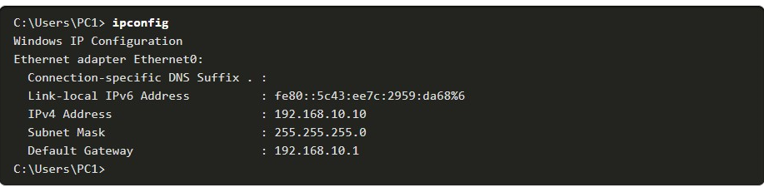

Next, verify connectivity with PC2 using the **ping** Windows host command, as shown in the output. The **ping** output successfully confirms inter-VLAN routing is operating.

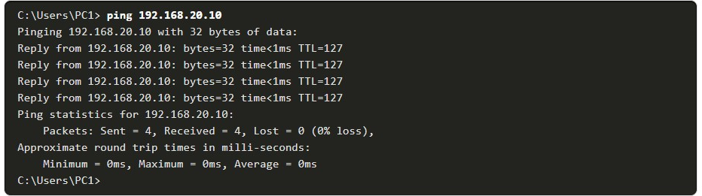

4.3.5

Routing on a Layer 3 Switch

If VLANs are to be reachable by other Layer 3 devices, then they must be advertised using static or dynamic routing. To enable routing on a Layer 3 switch, a routed port must be configured.

A routed port is created on a Layer 3 switch by disabling the switchport feature on a Layer 2 port that is connected to another Layer 3 device.

Specifically, configuring the **no switchport** interface configuration command on a Layer 2 port converts it into a Layer 3 interface. Then the interface can be configured with an IPv4 configuration to connect to a router or another Layer 3 switch.

4.3.6

Routing Scenario on a Layer 3 Switch

In the figure, the previously configured D1 Layer 3 switch is now connected to R1. R1 and D1 are both in an Open Shortest Path First (OSPF) routing protocol domain.

‘Assume inter-VLAN has been successfully implemented on D1. The G0/0/1 interface of R1 has also been configured and enabled. Additionally, R1 is using OSPF to advertise its two networks, 10.10.10.0/24 and 10.20.20.0/24.

**Note**: OSPF routing configuration is covered in another course. In this module, OSPF configuration commands will be given to you in all activities and assessments. It is not required that you understand the configuration in order to enable OSPF routing on the Layer 3 switch.

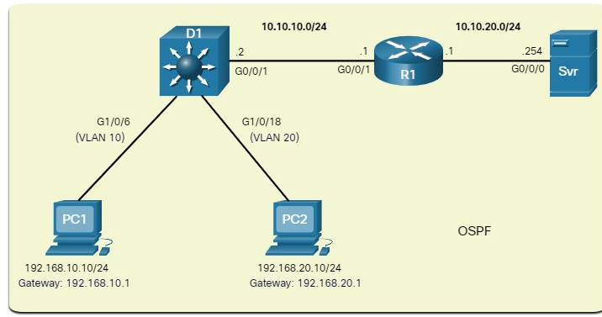

4.3.7

Routing Configuration on a Layer 3 Switch

Complete the following steps to configure D1 to route with R1:

**Step 1**. Configure the routed port.

**Step 2**. Enable routing.

**Step 3**. Configure routing.

**Step 4**. Verify routing.

**Step 5**. Verify connectivity.

**1. Configure the routed port.**

Configure G1/0/1 to be a routed port, assign it an IPv4 address, and enable it.

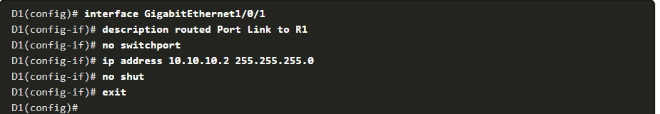

**2 Enable routing.**

Ensure IPv4 routing is enabled with the **ip routing** global configuration command



**3. Configure routing.**

Configure the OSPF routing protocol to advertise the VLAN 10 and VLAN 20 networks, along with the network that is connected to R1. Notice the message informing you that an adjacency has been established with R1.

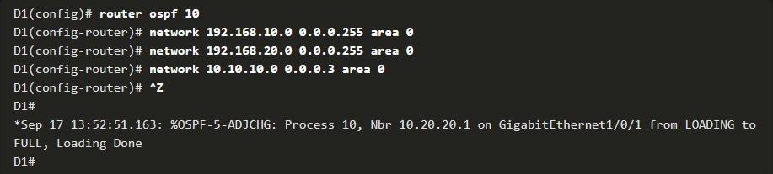

**4. Verify routing.**

Verify the routing table on D1. Notice that D1 now has a route to the 10.20.20.0/24 network

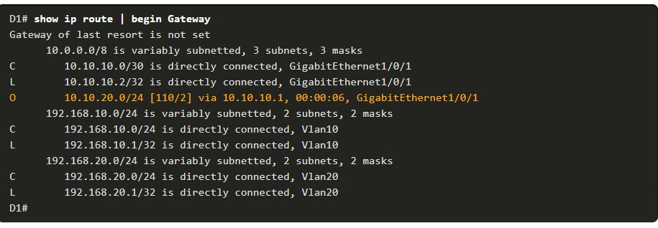

**5. Verify connectivity.**

At this time, PC1 and PC2 are able to ping the server connected to R1.

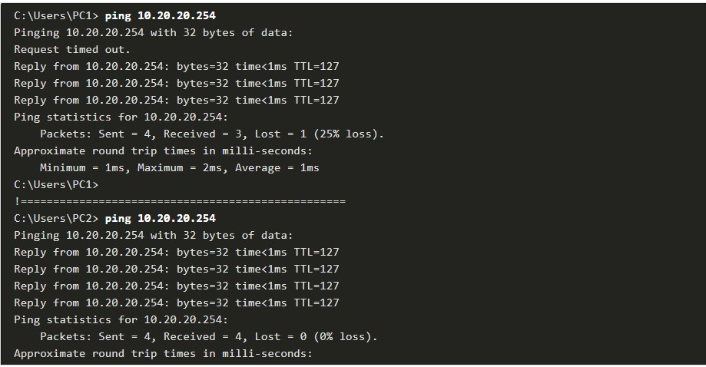

4.3.8

Packet Tracer - Configure Layer 3 Switching and Inter-VLAN Routing (pending)

In this activity, you will configure Layer 3 switching and Inter-VLAN routing on a Cisco 3560 switch.

**TROUBLESHOOT INTER-VLAN ROUTING**

4.4.1

Common Inter-VLAN Issues

By now, you know that when you configure and verify, you must also be able to troubleshoot. This topic discusses some common network problems associated with inter-VLAN routing.

There are a number of reasons why an inter-VLAN configuration may not work. All are related to connectivity issues.

First, check the physical layer to resolve any issues where a cable might be connected to the wrong port. If the connections are correct, then use the list in the table for other common reasons why inter-VLAN connectivity may fail.

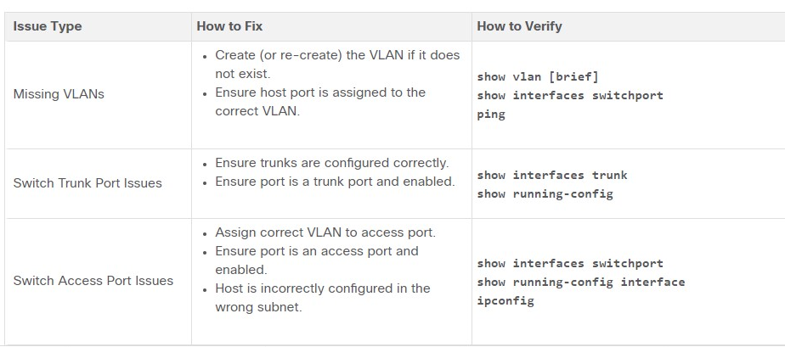

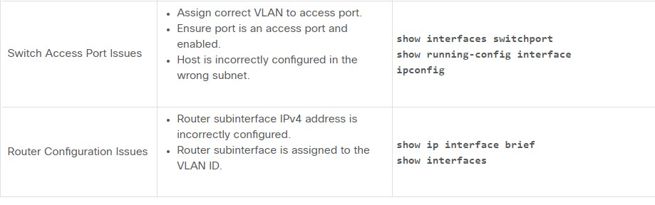

4.4.2

Troubleshoot Inter-VLAN Routing Scenario

Examples of some of these inter-VLAN routing problems will now be covered in more detail.

This topology will be used for all of these issues.

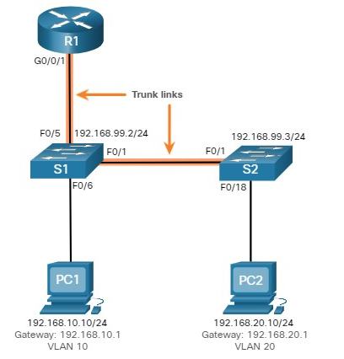

The VLAN and IPv4 addressing information for R1 is shown in the table.

### **Router R1 Subinterfaces**

| **Subinterface** | **VLAN** | **IP Address** |
| --- | --- | --- |
| G0/0/0.10 | 10 | 192.168.10.1/24 |
| G0/0/0.20 | 20 | 192.168.20.1/24 |
| G0/0/0.30 | 99 | 192.168.99.1/24 |

4.4.3

Missing VLANs

An inter-VLAN connectivity issue could be caused by a missing VLAN. The VLAN could be missing if it was not created, it was accidently deleted, or it is not allowed on the trunk link.

For example, PC1 is currently connected to VLAN 10, as shown in the **show vlan brief** command output.

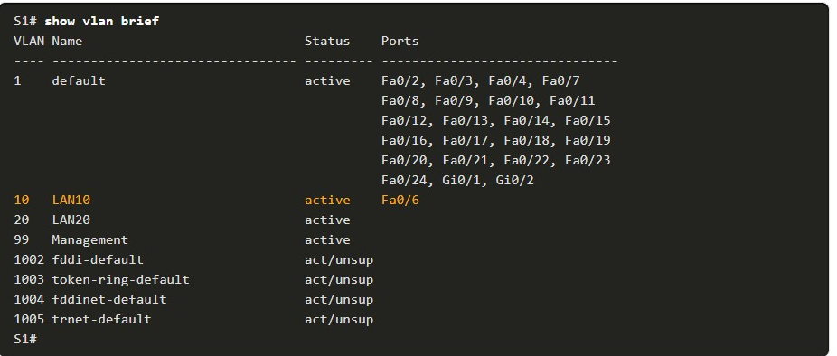

Now assume that VLAN 10 is accidently deleted, as shown in the following output.

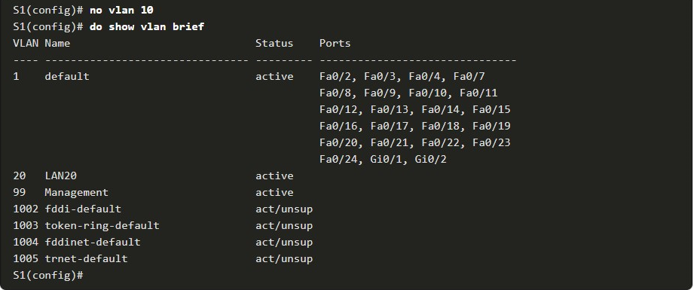

Notice VLAN 10 is now missing from the output. Also notice that port Fa0/6 has not been reassigned to the default VLAN.

The reason is because when you delete a VLAN, any ports assigned to that VLAN become inactive. They remain associated with the VLAN (and thus inactive) until you assign them to a new VLAN or recreate the missing VLAN.

Use the **show interface** interface-id **switchport** command to verify the VLAN membership.

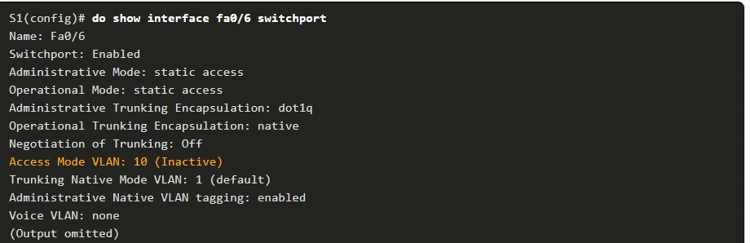

Recreating the missing VLAN would automatically reassign the hosts to it, as shown in the following output.

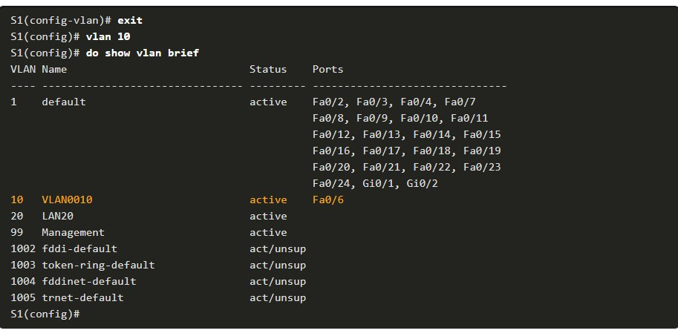

Now notice that the VLAN is included in the list and that the host connected to Fa0/6 is on VLAN 10.

4.4.4

Switch Trunk Port Issues

Another issue for inter-VLAN routing includes misconfigured switch ports. In a legacy inter-VLAN solution, this could be caused when the connecting router port is not assigned to the correct VLAN.

However, with a router-on-a-stick solution, the most common cause is a misconfigured trunk port.

For example, assume PC1 was able to connect to hosts in other VLANs until recently. A quick look at maintenance logs revealed that the S1 Layer 2 switch was recently accessed for routine maintenance. Therefore, you suspect the problem may be related to that switch.

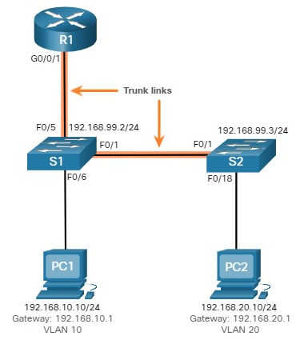

On S1, verify that the port connecting to R1 (i.e., F0/5) is correctly configured as a trunk link using the **show interfaces trunk** command, as shown.

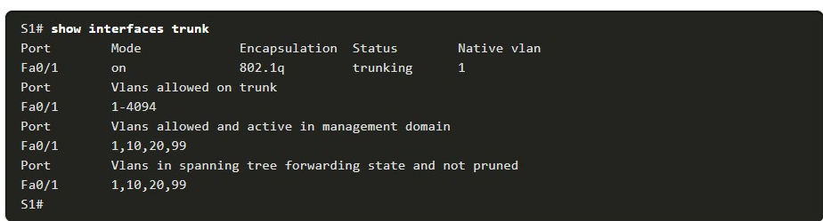

The Fa0/5 port connecting to R1 is mysteriously missing from the output. Verify the interface configuration using the **show running-config interface fa0/5** command, as shown.

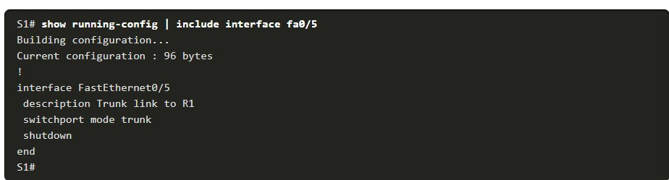

As you can see, the port was accidently shut down. To correct the problem, re-enable the port and verify the trunking status, as shown in the output.

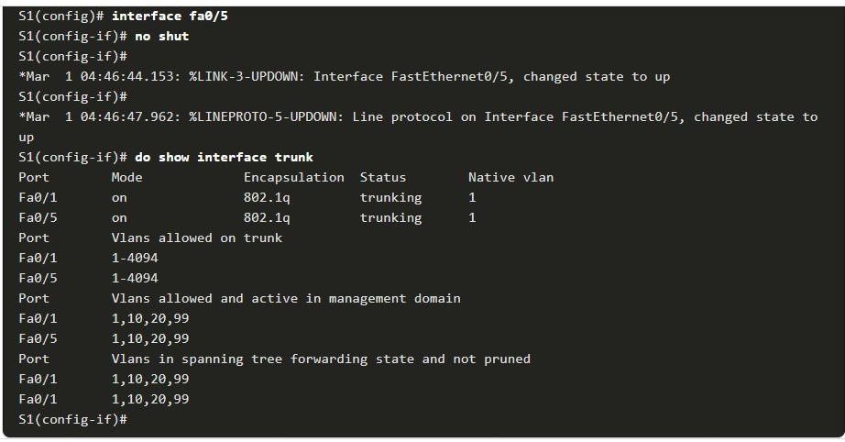

To reduce the risk of a failed inter-switch link disrupting inter-VLAN routing, redundant links and alternate paths should be part of the network design.

4.4.5

Switch Access Port Issues

When a problem is suspected with a switch access port configuration, use verification commands to examine the configuration and identify the problem.

Assume PC1 has the correct IPv4 address and default gateway but is not able to **ping** its own default gateway. PC1 is supposed to be connected to a VLAN 10 port.

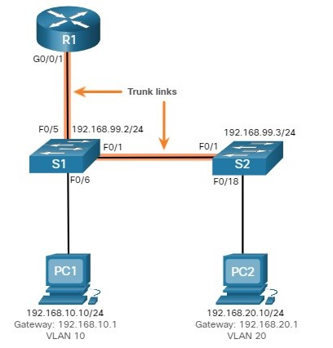

Verify the port configuration on S1 using the **show interfaces** interface-id **switchport** command.

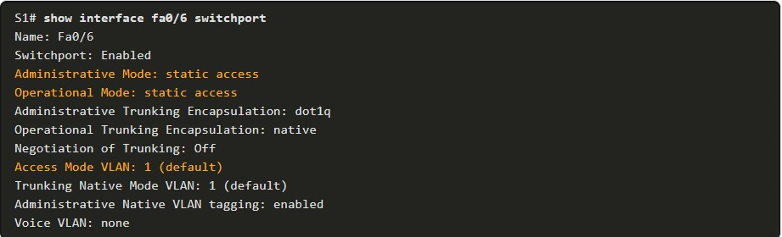

The Fa0/6 port has been configured as an access port as indicated by “static access”. However, it appears that it has not been configured to be in VLAN 10. Verify the configuration of the interface.

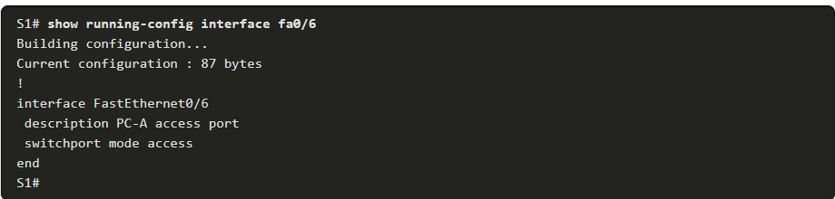

Assign port Fa0/6 to VLAN 10 and verify the port assignment.

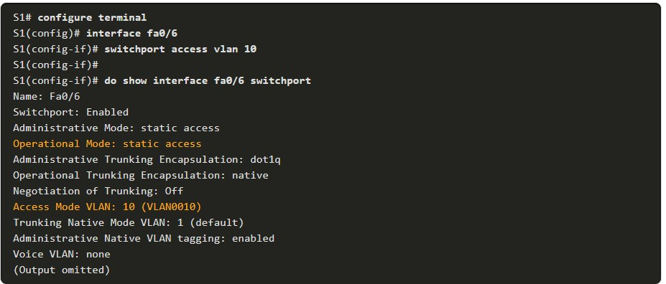

PC1 is now able to communicate with hosts on other VLANs.

4.4.6

Router Configuration Issues

Router-on-a-stick configuration problems are usually related to subinterface misconfigurations. For example, an incorrect IP address was configured or the wrong VLAN ID was assigned to the subinterface.

For example, R1 should be providing inter-VLAN routing for users in VLANs 10, 20, and 99. However, users in VLAN 10 cannot reach any other VLAN.



You verified the switch trunk link and all appears to be in order. Verify the subinterface status using the **show ip interface brief** command.

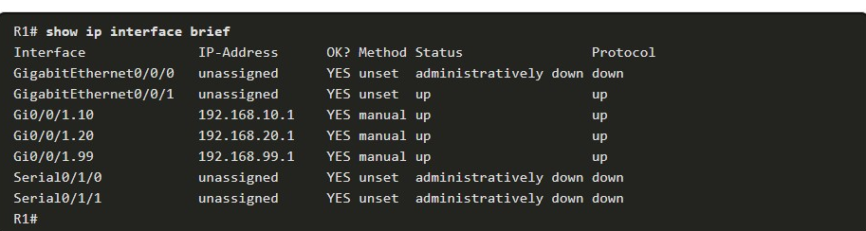

The subinterfaces have been assigned the correct IPv4 addresses and they are operational.

Verify which VLANs each of the subinterfaces is on. To do so, the **show interfaces** command is useful but it generates a great deal of additional unrequired output. The command output can be reduced using IOS command filters as shown in the output.

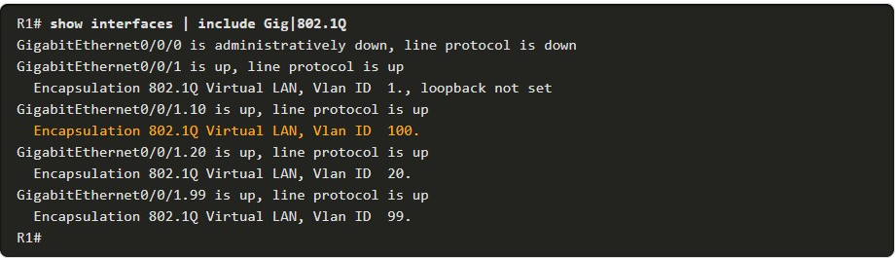

The pipe symbol (|) along with some select keywords is a useful method to help filter command output. In this example, the keyword **include** was used to identify that only lines containing the letters “Gig” or “802.1Q” will be displayed. Because of the way the **show interface** output is naturally listed, using these filters produces a condensed list of interfaces and their assigned VLANs.

Notice that the G0/0/1.10 interface has been incorrectly assigned to VLAN 100 instead of VLAN 10. This is confirmed by looking at the configuration of the R1 GigabitEthernet 0/0/1.10 subinterface, as shown.

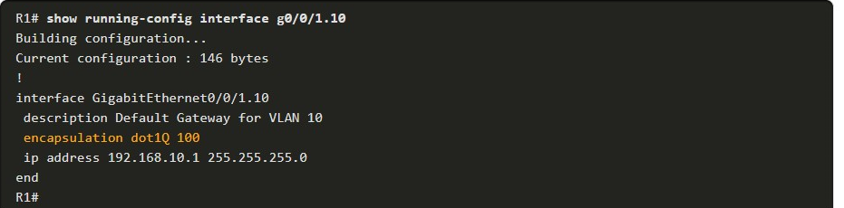

To correct this problem, configure subinterface G0/0/1.10 to be on the correct VLAN using the **encapsulation dot1q 10** subinterface configuration mode command.

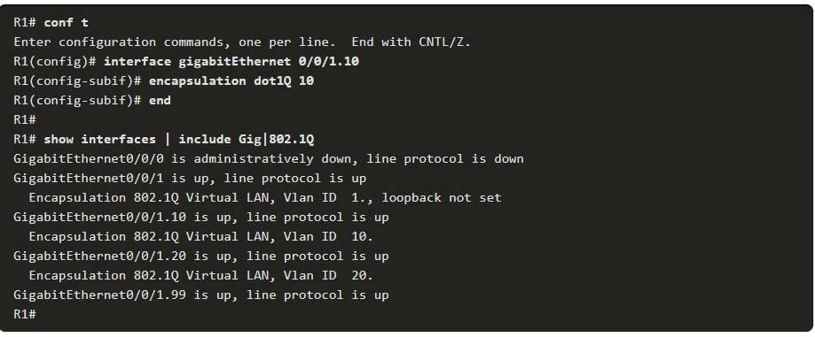

When the subinterface has been assigned to the correct VLAN, it is accessible by devices on that VLAN and the router can perform inter-VLAN routing.

With verification, router configuration problems are quickly addressed, allowing inter-VLAN routing to function properly.

1. You are troubleshSooting an inter-VLAN issue on a switch and need to verify that the subinterfaces are in the routing table. Which inter-VLAN routing troubleshooting command would you use to do this?



**show interfaces**



**show interfaces** *interface-id* **switchport**



**show ip interface brief**



**show ip route**



**show vlan**

**ANS:** ***The show ip route command would confirm if the subinterfaces are in the routing table.***

1. You are troubleshooting an inter-VLAN issue on a switch and need to check the list of VLANs and their assigned ports. Which inter-VLAN routing troubleshooting command would you use to do this?



**show interfaces**



**show interfaces** *interface-id* **switchport**



**show ip interface brief**



**show ip route**



**show vlan**

**ANS:** **The show vlan command would display the list of VLANs and their assigned ports**

1. You are troubleshooting an inter-VLAN issue on a router and need to verify the status of an access port and its access mode VLAN. Which troubleshooting command would you use to do this?



**show interfaces**



**show interfaces** *interface-id* **switchport**



**show ip interface brief**



**show ip route**



**show vlan**

**ANS:** **The show interfaces *interface-id* switchport command displays the port status and its access mode VLAN.**

1. You are troubleshooting an inter-VLAN issue on a router and need to verify the status and IP address of all interfaces in a condensed format. Which inter-VLAN routing troubleshooting command would you use to do this?



**show interfaces**



**show interfaces** *interface-id* **switchport**



**show ip interface brief**



**show ip route**



**show vlan**

**ANS: The show ip interfaces brief command is used to verify the status and IP address of all interfaces in a condensed format.**

4.4.8

## Packet Tracer - Troubleshoot Inter-VLAN Routing(PENDING)

In this Packet Tracer activity, you will complete the following objectives:

* Part 1: Locate Network Problems
* Part 2: Implement the Solution
* Part 3: Verify Network Connectivity

4.5.1

Packet Tracer - Inter-VLAN Routing Challenge

(PENDING)

In this activity, you will demonstrate and reinforce your ability to implement inter-VLAN routing, including configuring IP addresses, VLANs, trunking, and subinterfaces.

4.5.2

## Lab - Implement Inter-VLAN Routing

In this lab, you will complete the following objectives:

* Part 1: Build the Network and Configure Basic Device Settings
* Part 2: Create VLANs and Assign Switch Ports
* Part 3: Configure an 802.1Q Trunk between the Switches
* Part 4: Configure Inter-VLAN Routing on the S1 Switch
* Part 5: Verify Inter-VLAN Routing is Working

4.5.3

What did I learn in this module?

**Inter-VLAN Routing Operation**

Hosts in one VLAN cannot communicate with hosts in another VLAN unless there is a router or a Layer 3 switch to provide routing services.

***Inter-VLAN routing*** is the process of forwarding network traffic from one VLAN to another VLAN.

Three options include

* legacy,
* router-on-a-stick,
* Layer 3 switch using SVIs.

***Legacy*** used a router with multiple Ethernet interfaces. Each router interface was connected to a switch port in different VLANs.

Requiring one physical router interface per VLAN quickly exhausts the physical interface capacity of a router.

The ***‘router-on-a-stick’*** inter-VLAN routing method only requires one physical Ethernet interface to route traffic between multiple VLANs on a network. A Cisco IOS router Ethernet interface is configured as an 802.1Q trunk and connected to a trunk port on a Layer 2 switch.

The router interface is configured using subinterfaces to identify routable VLANs. The configured subinterfaces are ***software-based virtual interfaces***, associated with a single physical Ethernet interface.

The modern method is Inter-VLAN routing on a Layer 3 switch using SVIs. The SVI is created for a VLAN that exists on the switch. The SVI performs the same functions for the VLAN as a router interface. It provides Layer 3 processing for packets being sent to or from all switch ports associated with that VLAN.

**Router-on-a-Stick Inter-VLAN Routing**

To configure a switch with VLANs and trunking, complete the following steps:

* **create and name the VLANs,**
* **create the management interface,**
* **configure access ports,**
* **Configure trunking ports.**

The router-on-a-stick method requires a subinterface to be created for each VLAN to be routed.

A subinterface is created using the **interface** *interface_id subinterface_id* global configuration mode command.

Each router subinterface must be assigned an IP address on a unique subnet for routing to occur. When all subinterfaces have been created, the physical interface must be enabled using the **no shutdown** interface configuration command.

From a host, verify connectivity to a host in another VLAN using the **ping** command. Use **ping** to verify connectivity with the host and the switch. To verify and troubleshoot use the **show ip route**, **show ip interface brief**, **show interfaces**, and **show interfaces trunk** commands.

**Inter-VLAN Routing using Layer 3 Switches**

Enterprise campus LANs use Layer 3 switches to provide inter-VLAN routing. Layer 3 switches use hardware-based switching to achieve higher-packet processing rates than routers.

Capabilities of a Layer 3 switch include routing from one VLAN to another using multiple switched virtual interfaces (SVIs) and converting a Layer 2 switchport to a Layer 3 interface (i.e., a routed port).

To provide inter-VLAN routing, Layer 3 switches use SVIs. SVIs are configured using the same **interface vlan** *vlan-id* command used to create the management SVI on a Layer 2 switch.

A Layer 3 SVI must be created for each of the routable VLANs.

To configure a switch with VLANS and trunking, complete the following steps:

* **create the VLANS,**
* **create the SVI VLAN interfaces,**
* **configure access ports,**
* **enable IP routing.**

From a host, verify connectivity to a host in another VLAN using the **ping** command. Next, verify connectivity with the host using the **ping** Windows host command.

VLANs must be advertised using static or dynamic routing. To enable routing on a Layer 3 switch, a routed port must be configured.

A routed port is created on a Layer 3 switch by disabling the switchport feature on a Layer 2 port that is connected to another Layer 3 device. The interface can be configured with an IPv4 configuration to connect to a router or another Layer 3 switch. To configure a Layer 3 switch to route with a router, follow these steps:

* **configure the routed port,**
* **enable routing,**
* **configure routing,**
* **verify routing, and**
* **verify connectivity.**

**Troubleshoot Inter-VLAN Routing**

There are a number of reasons why an inter-VLAN configuration may not work. All are related to connectivity issues such as missing VLANs, switch trunk port issues, switch access port issues, and router configuration issues.

A VLAN could be missing if it was not created, it was accidently deleted, or it is not allowed on the trunk link.

Another issue for inter-VLAN routing includes misconfigured switch ports. In a legacy inter-VLAN solution, a misconfigured switch port could be caused when the connecting router port is not assigned to the correct VLAN.

With a router-on-a-stick solution, the most common cause is a misconfigured trunk port. When a problem is suspected with a switch access port configuration, use **ping** and **show interfaces** *interface-id* **switchport** commands to identify the problem.

Router configuration problems with router-on-a-stick configurations are usually related to subinterface misconfigurations. Verify the subinterface status using the **show ip interface brief** command.

4.5.4

## Module Quiz - Inter-VLAN Routing

Top of Form

1. A PC is to access a web server on another network. Which inter-VLAN method will provide the highest bandwidth at Layer 3 and also provide a default gateway for the PC?

Topic 4.3.0 - A router-on-a-stick design is the same as having a trunked interface between the router and the switch. This design works, but does not scale well because all VLANs must traverse the one connection between the router and the switch. Multiple physical interfaces on the router would be faster than the router-on-a-stick design, but a router has a limited number of physical interfaces. Layer 3 switches with routing enabled have more Ethernet ports as well as the ability to route.



trunked interface between the router and the switch



router on a stick



multilayer switch with routing enabled



multiple physical interfaces on the router, all connected to a Layer 2 switch

1. Which scalable method must be implemented in order to provide inter-VLAN routing on a switched network with more than 1000 VLANs?

Topic 4.1.0 - Layer 2 switches are able to perform static routing, but this method is inefficient with a large number of VLANs. Multilayer switching is more scalable than any other inter-VLAN routing implementation, with traffic being routed internally to the switch device. In router-on-a-stick inter-VLAN routing, where a single physical interface routes traffic among multiple VLANs on a network, there is no practical scalability. The legacy inter-VLAN routing is very inefficient and is no longer used in switched networks, because each VLAN requires a physical router interface that is connected to a different physical switch port.



connecting each physical router interface to a different physical switch port, with each switch port assigned to a different VLAN



routing traffic internally to a Layer 3 switch device



connecting a router interface to a switch port that is configured in trunk mode to route packets between VLANs, with each VLAN assigned to a router subinterface​



configuring static routes on a Layer 2 switch device

1. When configuring a router as part of a router-on-a-stick inter-VLAN routing topology, where should the IP address be assigned?

Topic 4.2.0 - The IP address and the encapsulation type should be assigned to each router subinterface in a router-on-a-stick inter-VLAN topology.



to the interface



to the VLAN



to the SVI



to the subinterface

1. A small college uses VLAN 10 for the classroom network and VLAN 20 for the office network. What is needed to enable communication between these two VLANs while using legacy inter-VLAN routing?

Topic 4.1.0 - With legacy inter-VLAN routing, different physical router interfaces are connected to different physical switch ports. The switch ports that connect to the router are in access mode, each belonging to a different VLAN. Switches can have ports that are assigned to different VLANs, but communication between VLANs requires routing function from the router.



A router with one VLAN interface is needed to connect to the SVI on a switch.



A router with at least two LAN interfaces should be used.



Two groups of switches are needed, each with ports that are configured for one VLAN.



A switch with a port that is configured as trunk is needed to connect to a router.

1. What is a disadvantage of using multilayer switches for inter-VLAN routing?

Topic 4.1.0 - The main disadvantage of the multilayer switches is their higher cost. Because both routing and switching are done in hardware, multilayer switches are faster than router-on-a-stick.



Multilayer switches are limited to using trunk links for Layer 3 routing.



Multilayer switches have higher latency for Layer 3 routing.



Multilayer switches are more expensive than router-on-a-stick implementations.



Spanning tree must be disabled in order to implement routing on a multilayer switch.

1. Which type of inter-VLAN communication design requires the configuration of multiple subinterfaces?

Topic 4.1.0 - The router-on-a-stick design always includes subinterfaces on a router. When a multilayer switch is used, multiple SVIs are created. When the number of VLANs equals the number of ports on a router, or when the management VLAN needs to be routed, any of the inter-VLAN design methods can be used.



routing for the management VLAN



legacy inter-VLAN routing



router on a stick



routing via a multilayer switch

1. What is a disadvantage of using router-on-a-stick inter-VLAN routing?

Topic 4.1.0 - Router-on-a-stick inter-VLAN routing does not scale beyond 50 VLANs. The router can receive VLAN-tagged packets and send VLAN-tagged packets to a destination. Router-on-a-stick inter-VLAN routing can utilize a single router interface as a trunk link to receive and forward VLAN traffic and does not require multiple interfaces.



does not scale well beyond 50 VLANs



does not support VLAN-tagged packets



requires the use of multiple router interfaces configured to operate as access links



requires the use of more physical interfaces than legacy inter-VLAN routing

1. What is the meaning of the number 10 in the **encapsulation dot1Q 10 native** router subinterface command?​

Topic 4.2.0 - The administrator can use the encapsulation command to specify the encapsulation type (IEEE 802.1Q or ISL), the VLAN ID, and optionally the native VLAN.



the subinterface number​



the subnet number



the VLAN ID



the interface number

1. While configuring inter-VLAN routing on a multilayer switch, a network administrator issues the **no switchport** command on an interface that is connected to another switch. What is the purpose of this command?

Topic 4.3.0 - When a Layer 2 interface on a multilayer switch is configured with the **no switchport** command, it becomes a routed port. A routed port is configured with an IP address for a specific subnet.



to create a routed port for a single network



to provide a static trunk link



to create a switched virtual interface



to provide an access link that tags VLAN traffic

1. A network administrator enters the following command sequence on a Cisco 3560 switch. What is the purpose of these commands?

Switch(config)# **interface gigabitethernet 0/1**  
Switch(config-if)# **no switchport**

Topic 4.3.0 - By default, the physical ports on a 3560 switch are Layer 2 interfaces. To make them routed ports, the interface command **no switchport** should be used. The other options do not describe the purpose of this command.



to shut down the Gi0/1 port



to make the Gi0/1 port a routed port



to enable the Gi0/1 port as a switch virtual interface



to enable the Gi0/1 port as a bridge virtual interface

1. What operational mode should be used on a switch port to connect it to a router for router-on-a-stick inter-VLAN routing?

Topic 4.2.0 - Routers do not support Dynamic Trunking Protocol, and access mode is used to connect hosts.



dynamic desirable



dynamic auto



trunk



access

1. Which sentence correctly describes the SVI inter-VLAN routing method?

Topic 4.1.0 - In order to create SVI inter-VLAN routing on a Layer 3 switch, the VLAN must exist in the database and the SVI must be explicitly created. The only exception is VLAN1, which is created by default.



The encapsulation type must be configured on the SVI.



A physical interface is needed for every VLAN that is created.



Subinterfaces have to be created.



An SVI is needed for each VLAN.

1. How is traffic routed between multiple VLANs on a multilayer switch?

Topic 4.1.0 - Multilayer switches can perform inter-VLAN routing by the use of internal VLAN interfaces. External physical interfaces can receive traffic but are not necessary for routing functions. When routing between VLANs, any broadcast traffic that is received on a VLAN would remain on ports that are members of that VLAN. Subinterfaces are not usable for inter-VLAN routing on multilayer switches.



Traffic is routed via internal VLAN interfaces.



Traffic is broadcast out all physical interfaces.



Traffic is routed via subinterfaces.



Traffic is routed via physical interfaces.

1. What is required to perform router-on-a-stick inter-VLAN routing?

Topic 4.2.0 - With router-on-a-stick inter-VLAN routing, a single physical router interface is used to route packets between multiple VLANs if the interface is configured with multiple subinterfaces. A separate subinterface is needed for each VLAN that will be routed. Because the router is performing all routing functions, a multilayer switch is not required.



a multilayer switch



a router with multiple physical interfaces



a Layer 2 switch that is configured with multiple trunk ports



a router that is configured with multiple subinterfaces

1. An administrator was troubleshooting a router-on-a-stick topology and concluded that the problem was related to the configuration of VLANs on the router subinterfaces. Which two commands can the administrator use in the router to identify the problem? (Choose two.)

Topic 4.4.0 - The **show ip interface** and **show running-config** commands can be useful in troubleshooting routing issues like wrong VLAN IDs that are assigned to subinterfaces. The **show controllers and** **show ip protocols** commands do not display any information about VLANs. The **show vlan** command is not useful to show information about the router subinterfaces.



**show ip protocols**



**show vlan**



**show running-config**



**show controllers**



**show ip interface**